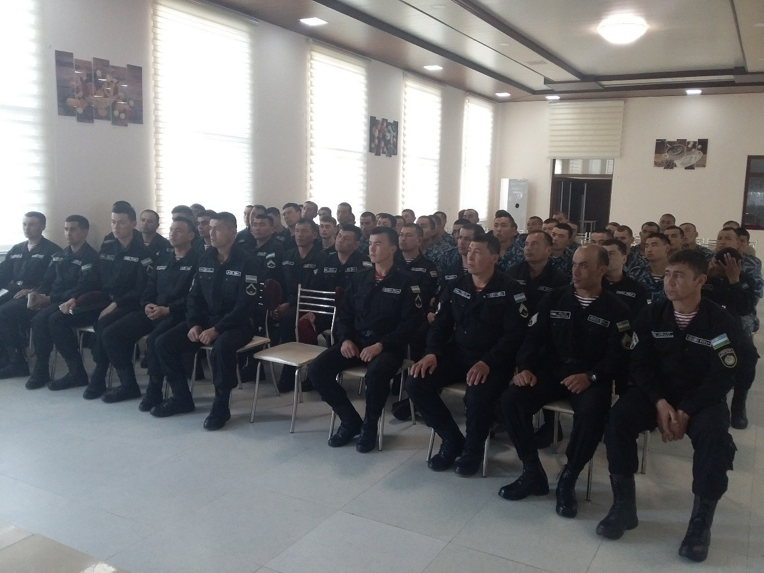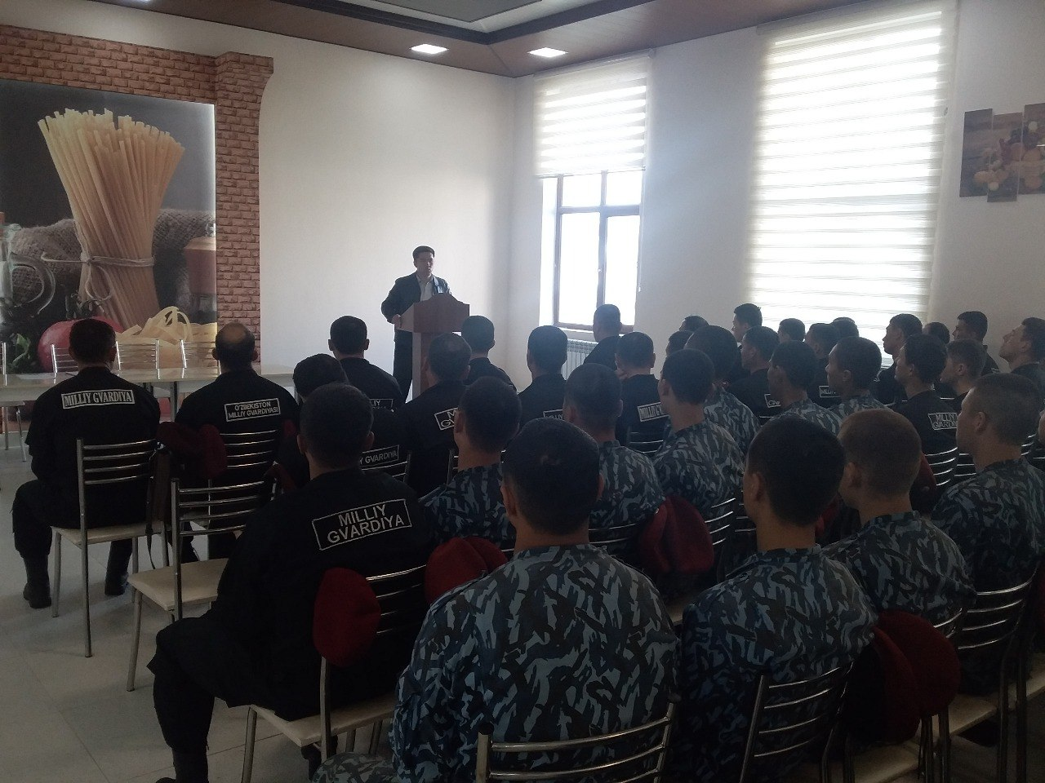
Mamajonov Ikboljon, a teacher at the Department of History of Uzbekistan, Andijan State University, held a roundtable discussion with the leaders and staff of the Andijan region of the National Guard of Uzbekistan on the topic "The Book of Temur's Statutes - the basis of public administration." During the conversation, they got acquainted with the work of Amir Temur "Temur's Statutes" and received answers to their questions.
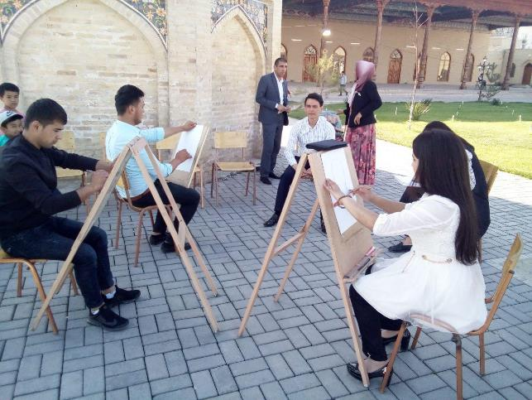

Talented members of the circle demonstrate their creative work on Registan Square in the Old City on Fridays
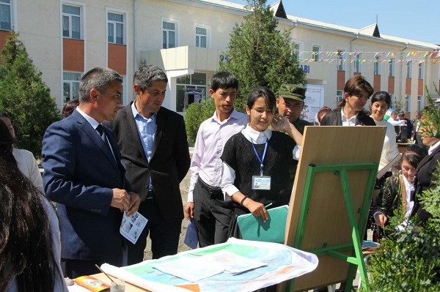

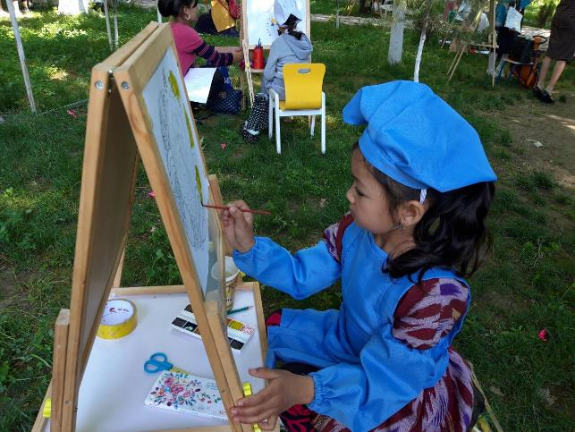

Students of the Faculty of History in collaboration with the Ulugnor district administration held a spiritual and educational event under the motto "We are looking for talents."
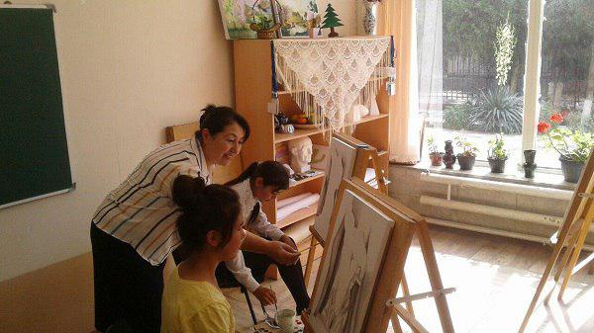

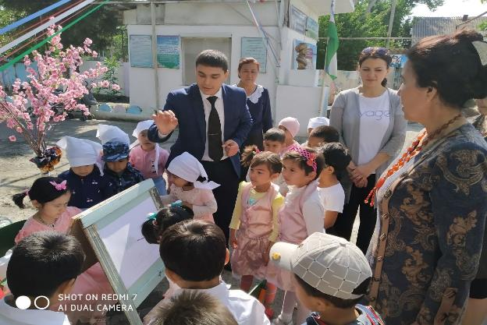

University professors organized a spiritual and educational event under the motto "My art is my pride" in Andijan Pedagogical College and the 24th DPE in Andijan
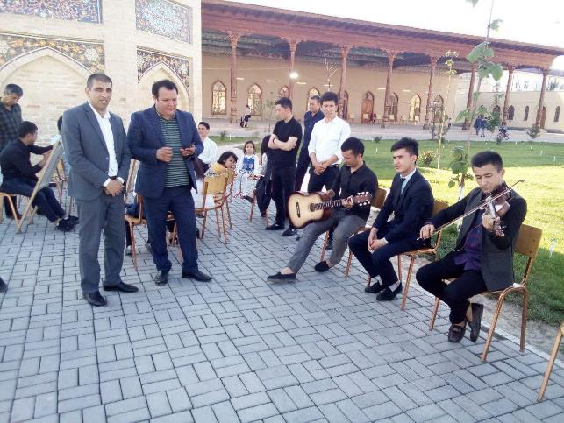

Professors and students of the Department of Music Education on the initiative of the President to increase the interest of young people in art

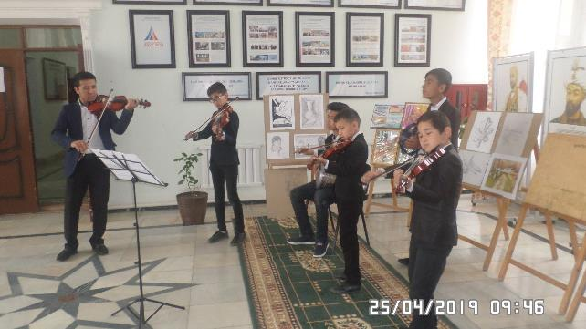

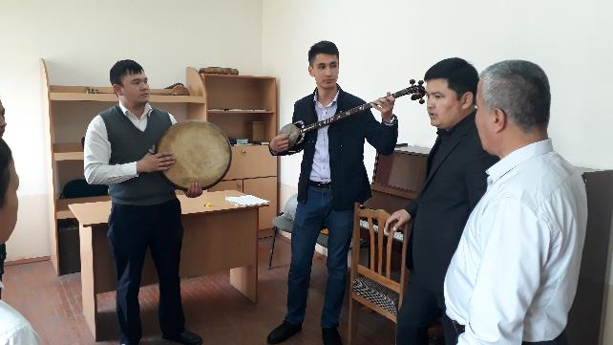

Teachers of the music department K.Toshtemirov conducted a MASTER CLASS at the children's boarding school No. 10 in Asaka district, and J.Muydinov at the children's school of music and art No. 4 in Kurgantepa district.

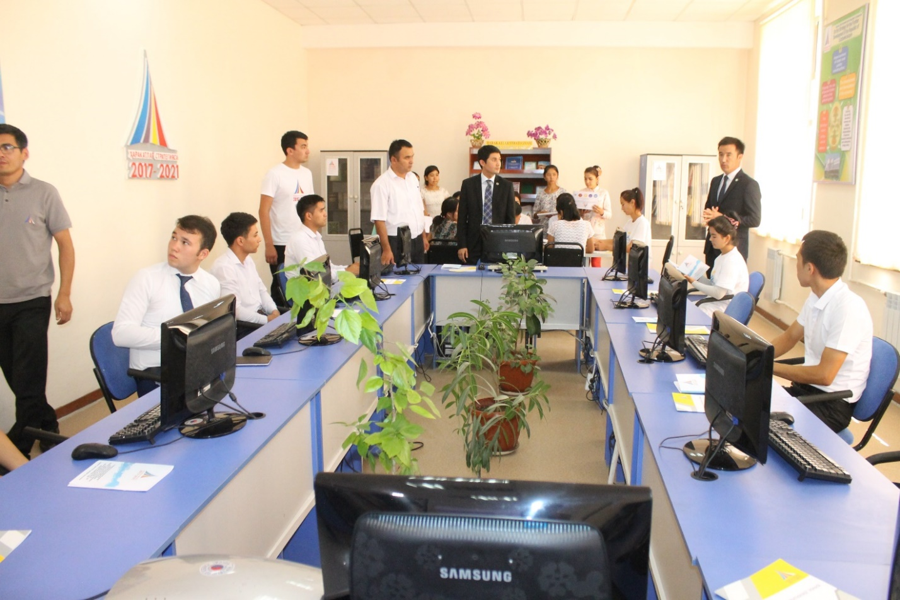
In June 2019, as part of the "Youth Month", a meeting was held with students of the training course for talented youth, organized by the regional council of the Youth Union. Vice-Rector for Youth Affairs A.Hamrakulov and the leader of the Youth Union of ASU E.Kholmirzaev took part.

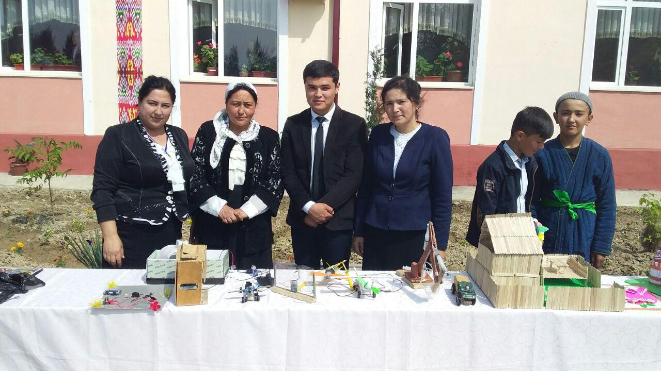

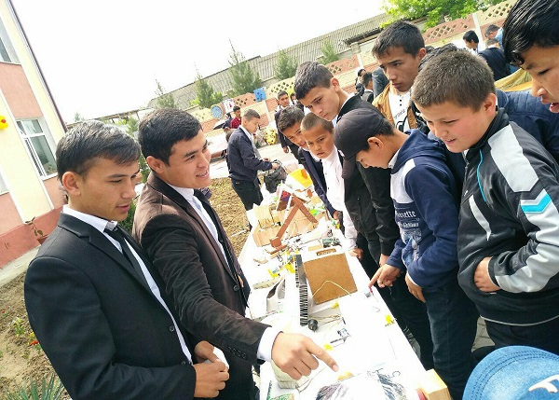

Open fairs have been organized in secondary schools in Andijan as part of 5 important initiatives. Talented students of the university participated in the fair with their discoveries.
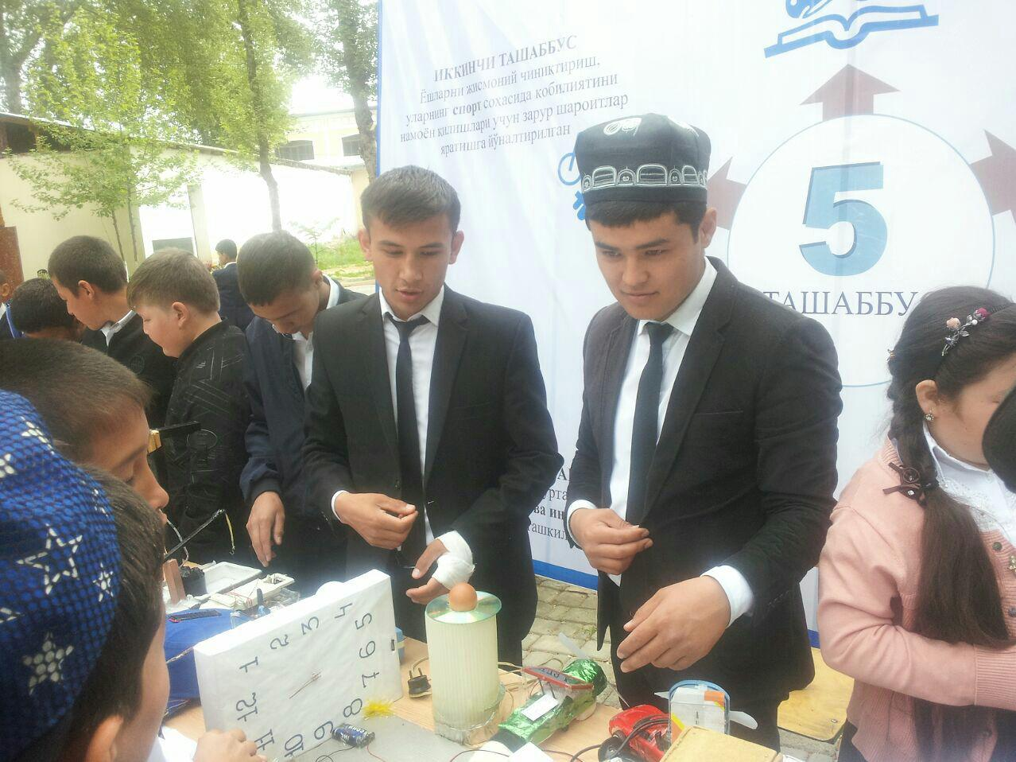

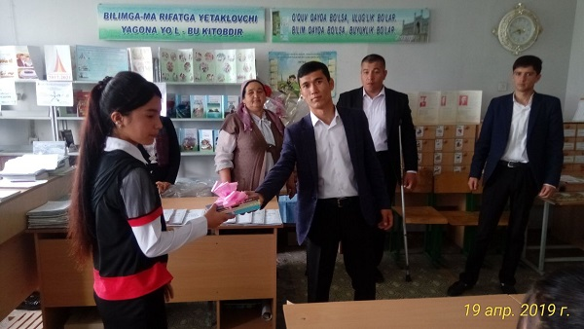

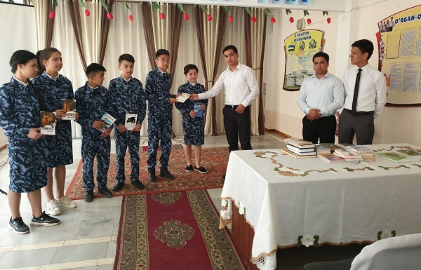

Book distribution campaign under the motto "My gift to the school I attended" was held in secondary schools of Andijan

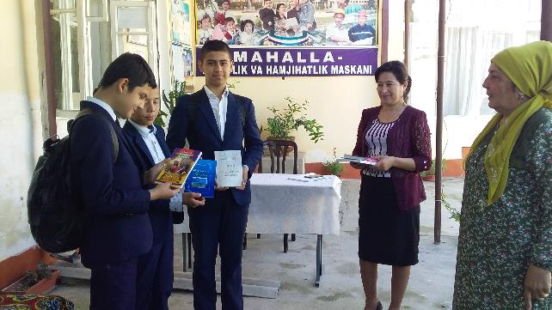

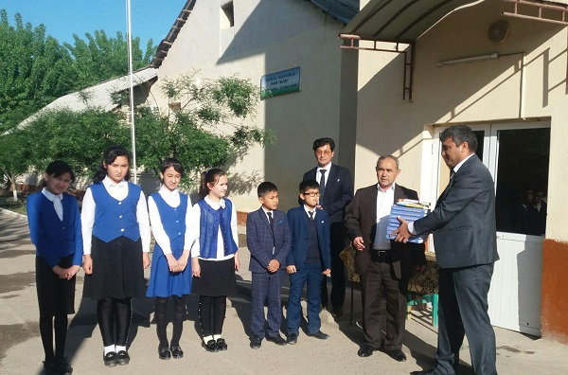

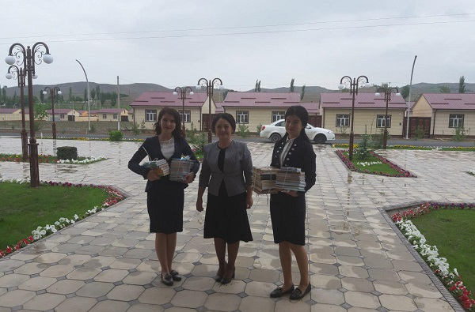

At the initiative of Andijan State University, more than 1,000 books were delivered to free libraries

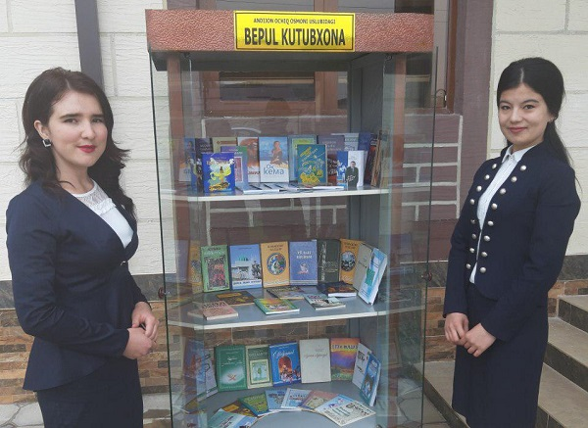

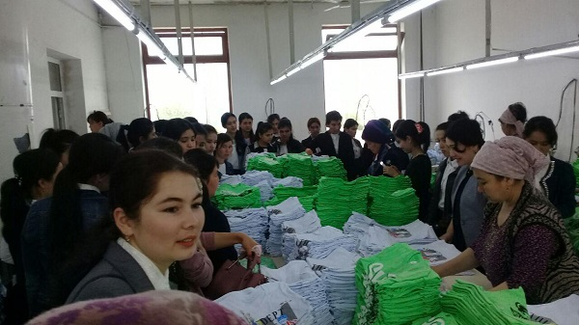

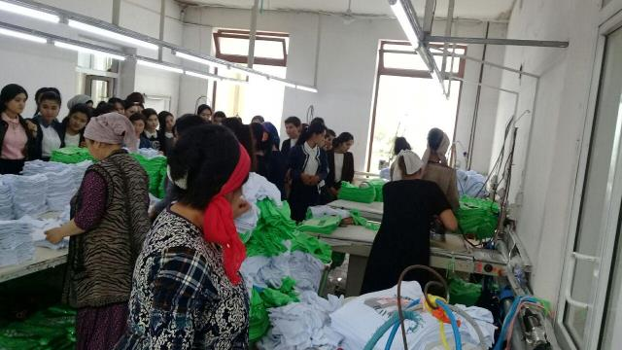

Our students get acquainted with the conditions created for women workers at Bogishamol Textile Lux

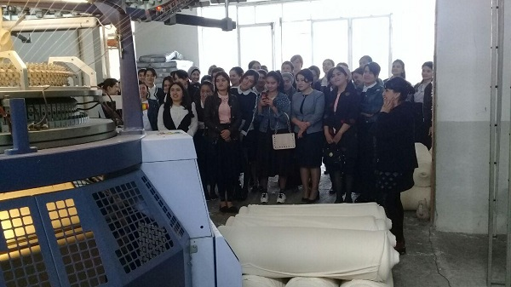

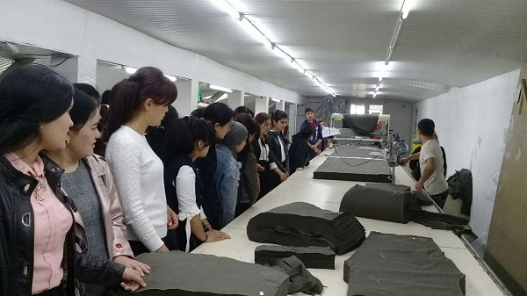

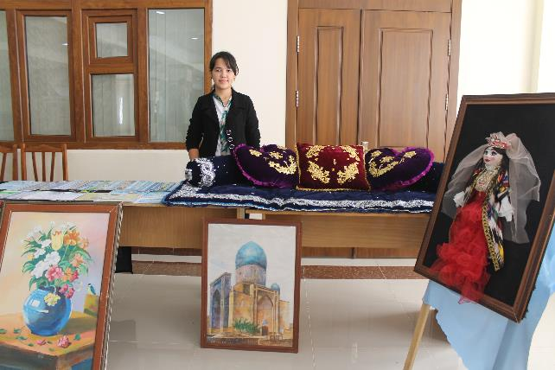

An exhibition of handicrafts created by female students was held at the university
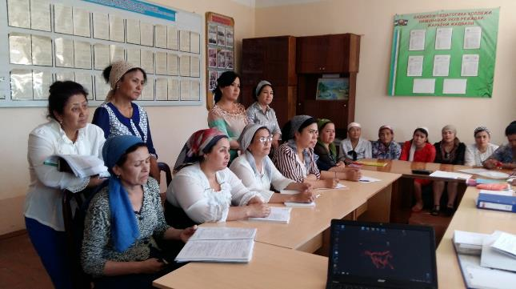

Meeting with teachers of Andijan Pedagogical College on "Employment of women"

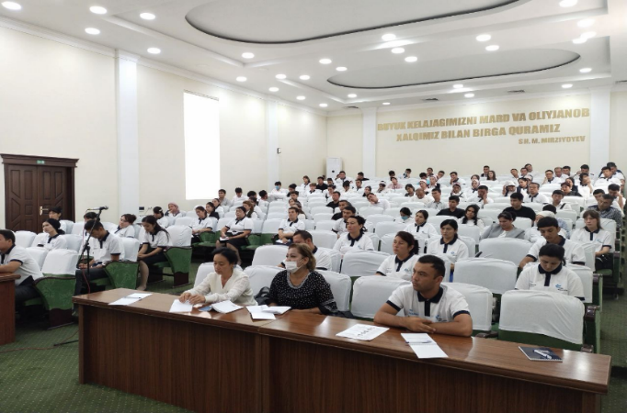

On September 22-23, 2021, Yusufkhan Jahongirov, a doctoral student of the Department of Theory of Civil Society, visited Khanabad, where future leaders took part in a meeting of youth activists on the future and responsibility of the election campaign.
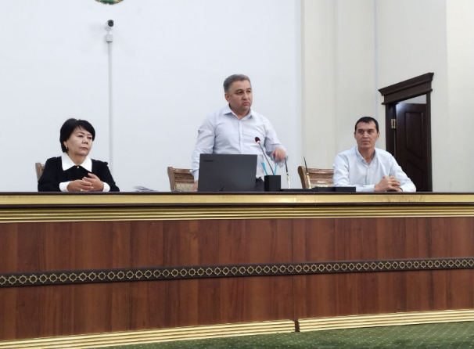
On September 8, 2021, the senior teacher of the department Hayitmatov Zoxidjon visited the Department of the National Guard of Andijan region and returned for a roundtable discussion on "Let's live freely and prosperously in the new Uzbekistan.

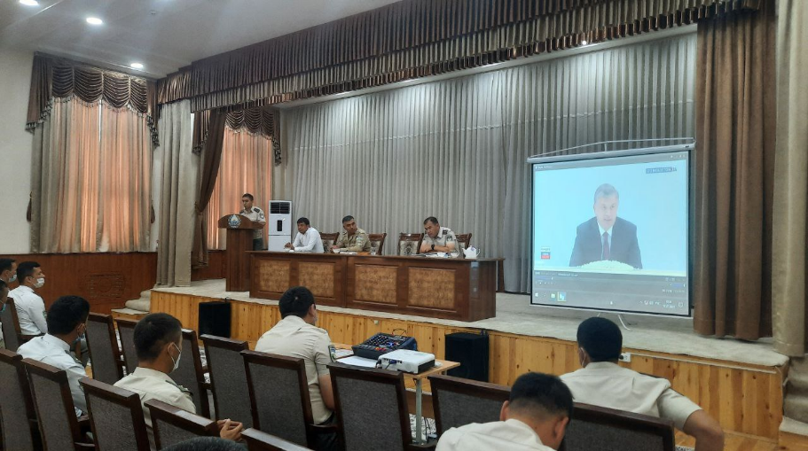

On October 11, 2021, the teacher of the department Khoshimjanov Sharobiddin visited the Transport Department of the Andijan Department of Internal Affairs and took part in a round table on "The Afghan problem in peacekeeping."
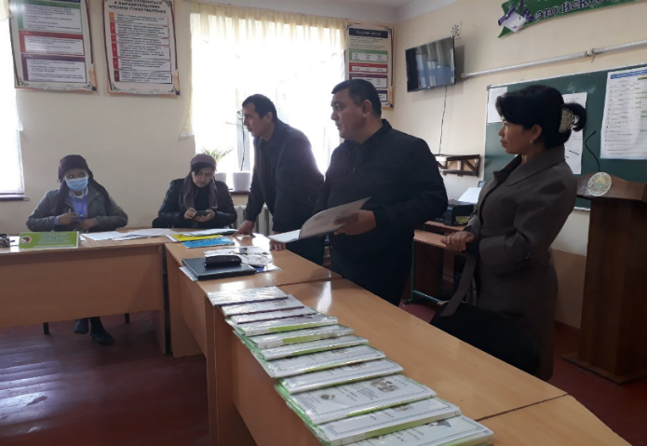

On September 2-10, 2021, psychologist O. Mukhtarov conducted psychocorrectional talks with the families of citizens of Uzbekistan who were members of terrorist groups in Syria and Iraq at an event organized by the DXX in Andijan, Kurgantepa and Marhamat districts.
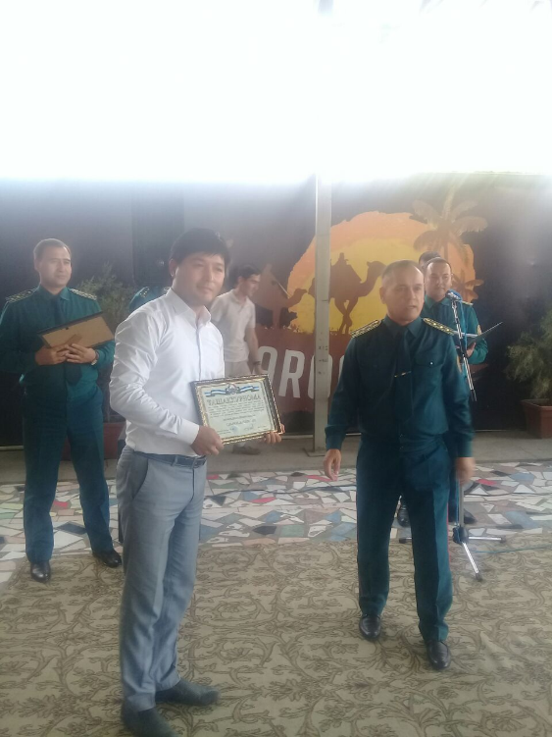
University psychologist O. Mukhtarov in cooperation with the Women's Council of Andijan region and the Women's Council of AUL in April and May 2021 held a seminar on "Factors of premarital maturity" for young girls.
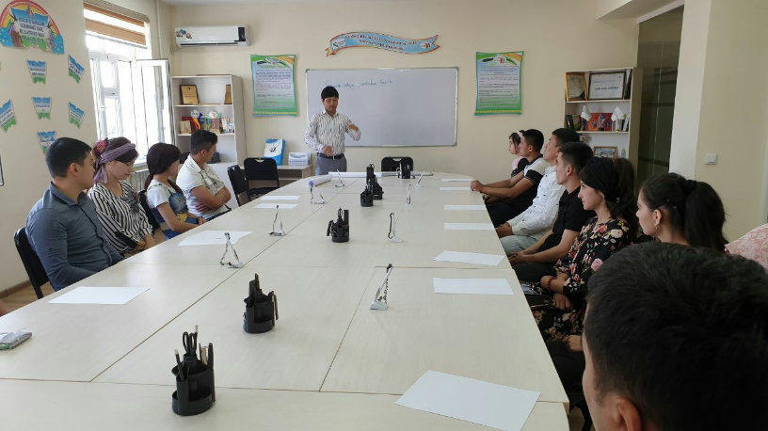

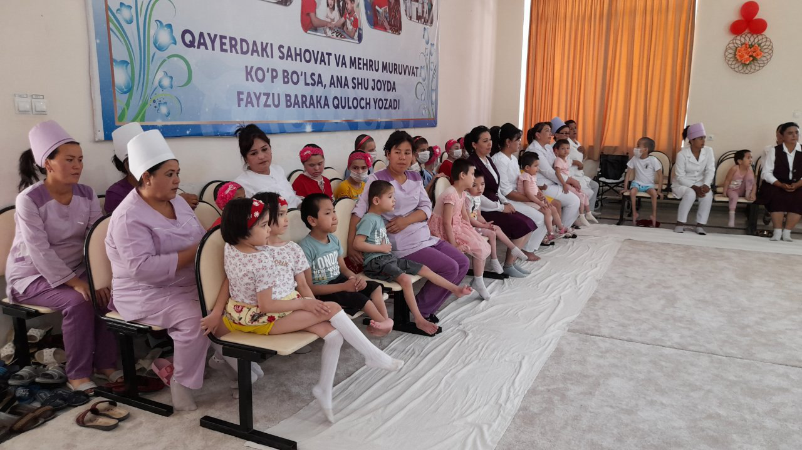

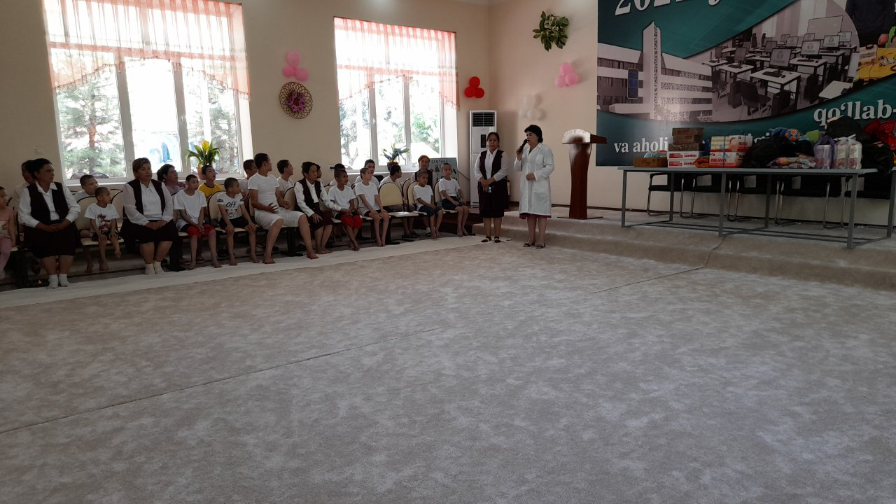

Tasks set out in the Resolution of the President of the Republic of Uzbekistan dated August 9, 2021 PC-5215 "Introduction of a radically updated system of education of orphans and children deprived of parental care" and the Ministry of Higher and Secondary Special Education August 16, 2021 Excerpts from a visit to the boarding school "House of Mercy" in Qurghonteppa in order to ensure the implementation of the tasks set out in the "Program of Action"

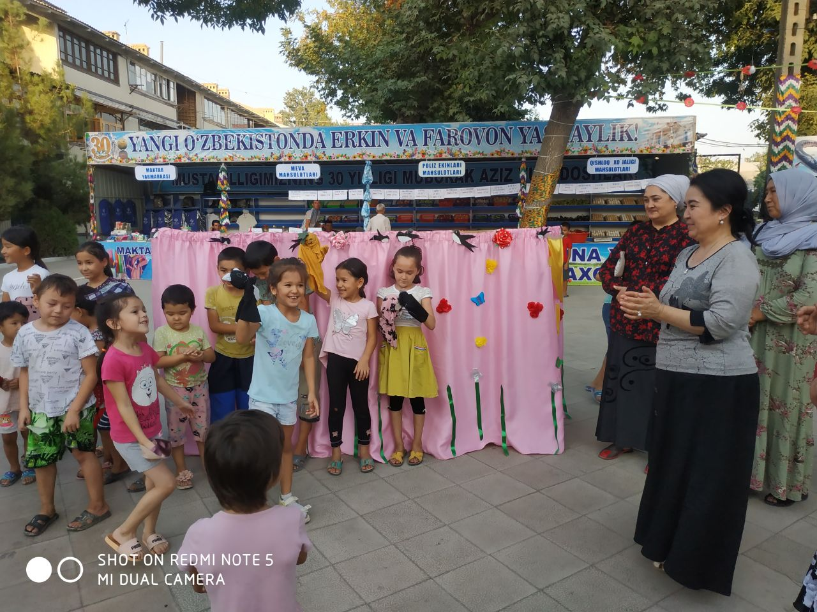

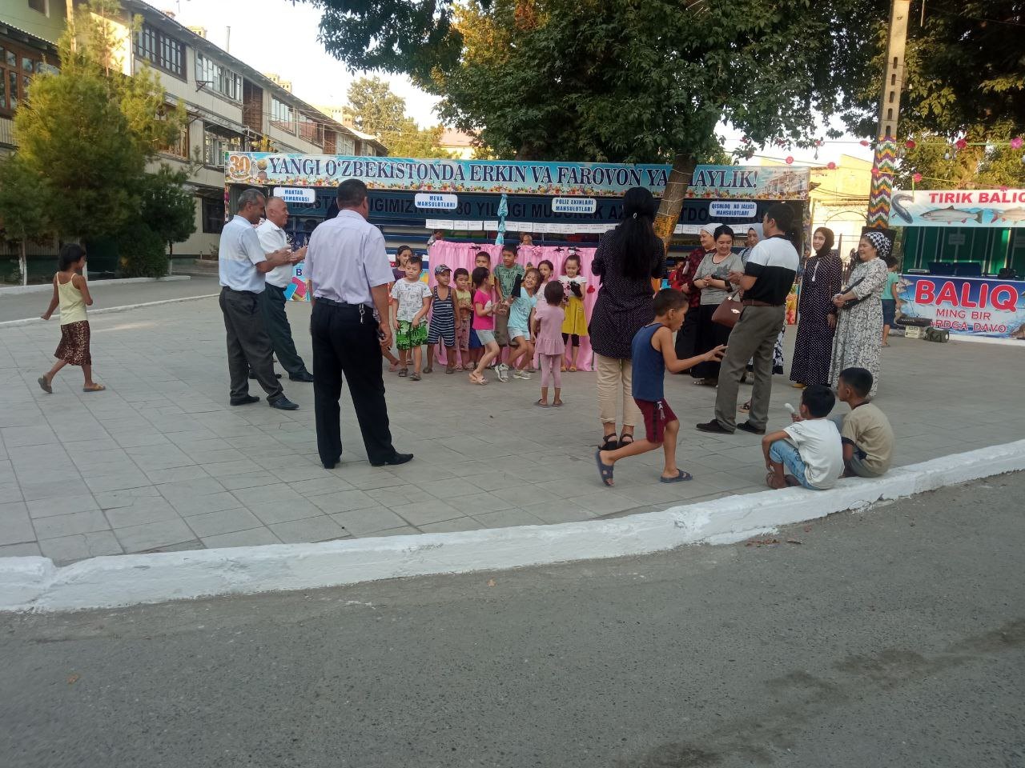

On August 23, 2021, an event dedicated to the 30th anniversary of Independence of our Motherland was held on the territory of Dukchi Eshan Farm in Andijan under the motto "Let's live freely and prosperously in the new Uzbekistan."

Performances of the creative team of the university youth orchestra "Nihol" at the meeting of citizens of the mahalla "Takhtakoprik" Andijan

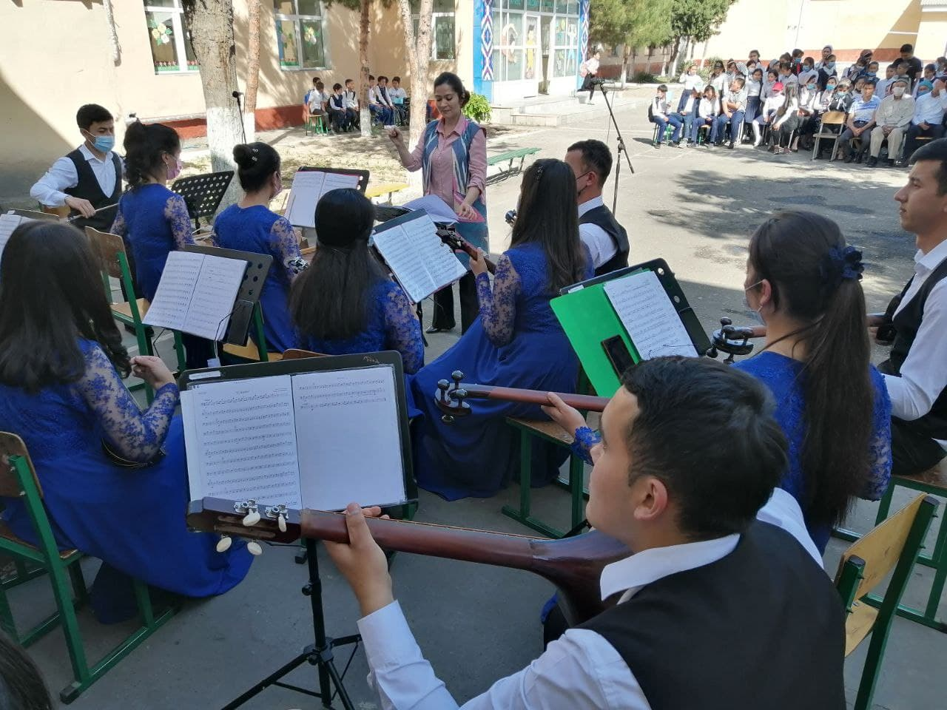

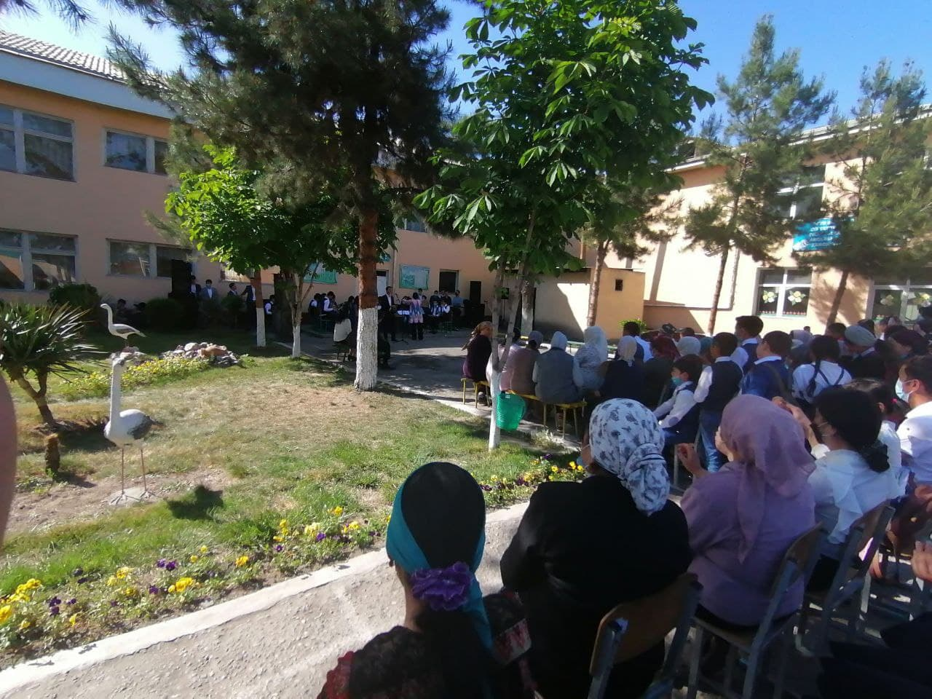
Performances of the team of the student theater studio "Humo" consisting of talented students of the university in the mahalla "Navbahor" in the framework of the month of culture

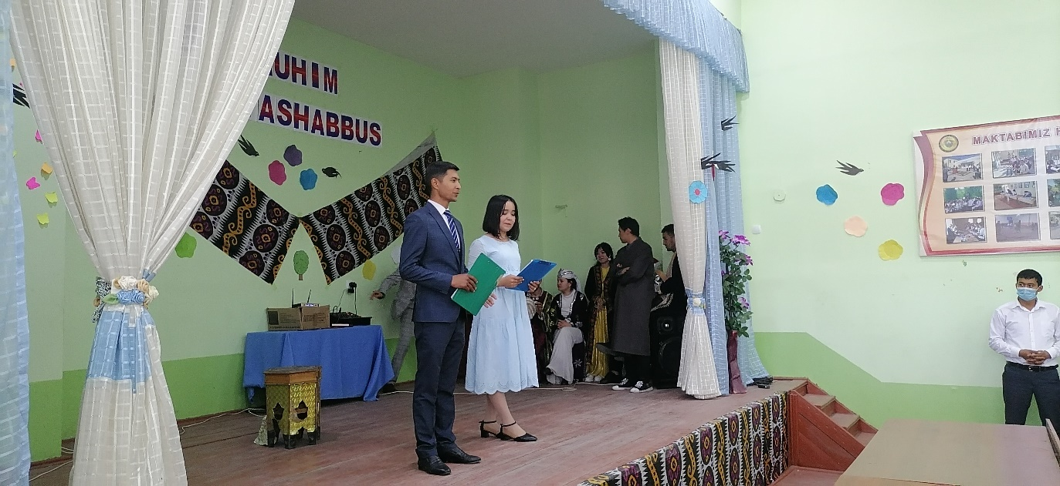

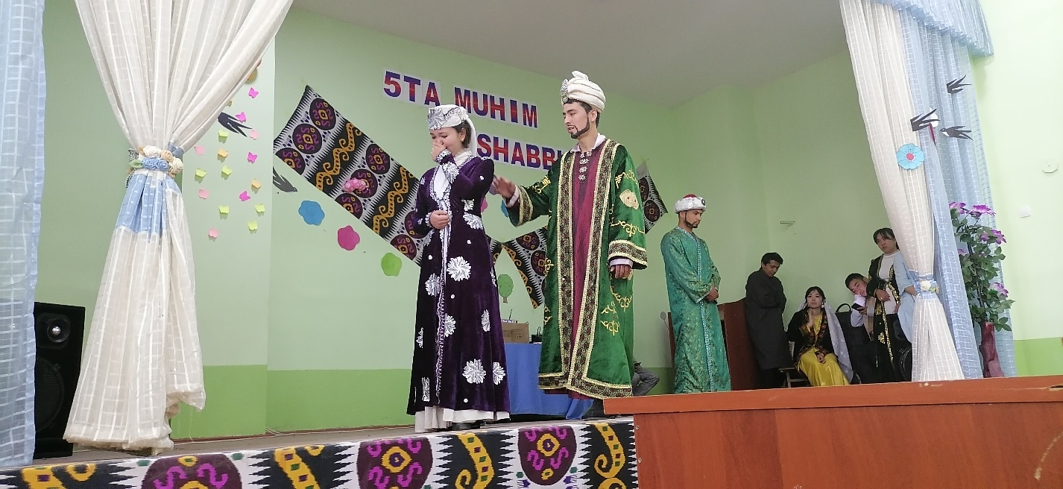

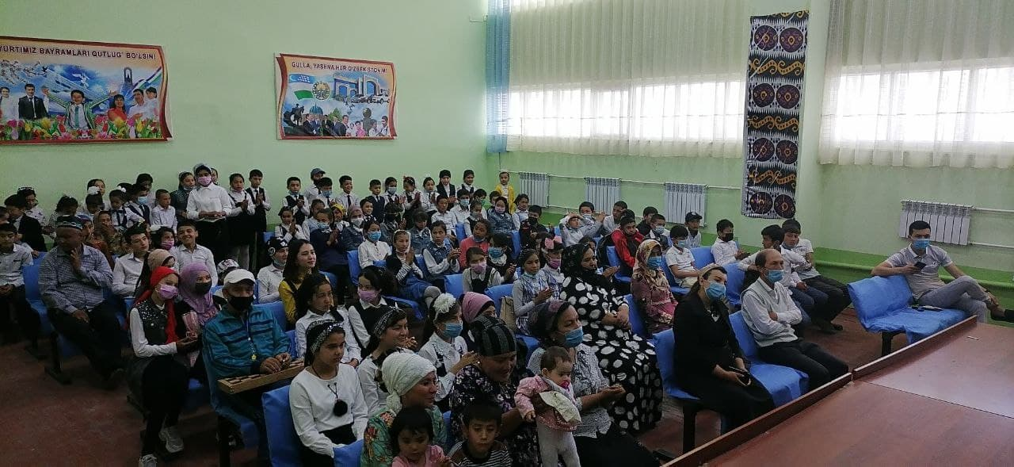

On April 27, 2021, the student art and creative team "Nihol" of the Faculty of Arts of Andijan State University performed in front of the residents of "Takhta Koprik" in Andijan in accordance with the plan of the regional "Month of Culture". and unorganized youth attended.
On the same day, the students' theater studio "Humo", consisting of talented students of the university, organized a cultural event for the population in the mahalla "Navbahor" Shahrihan district. The event was attended by more than 80 citizens and unorganized youth.
A similar cultural event was organized by the universal team "Cheerful and clever" of the primary organization of the Youth Union of the University at the meeting of citizens of "Soyboyi" mahalla of Pakhtaabad district. More than 200 people took part in the event.

