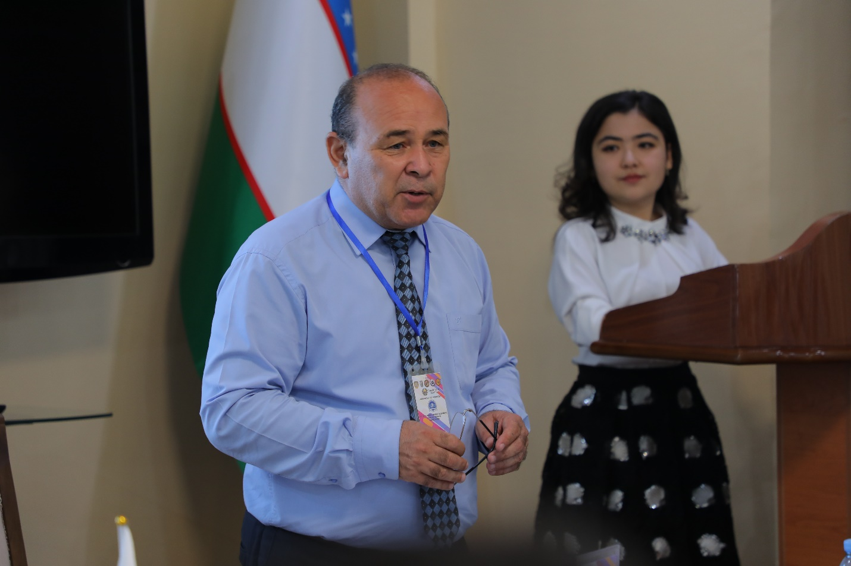

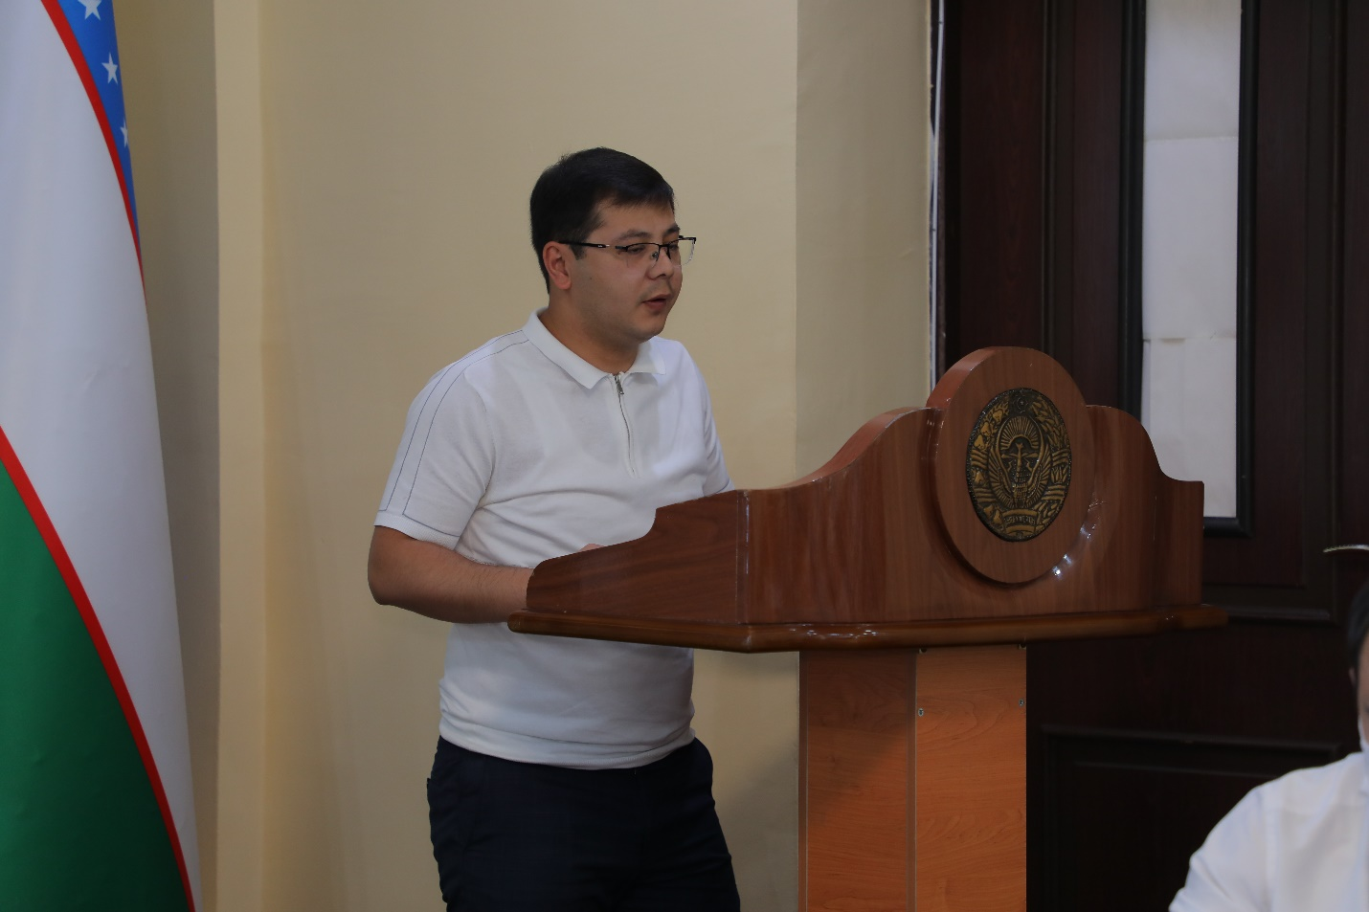

On August 28, 2021, the Youth Union of Uzbekistan in cooperation with the Andijan Regional Council, the regional Interior Ministry and Andijan State University held a meeting on "Protecting young people from destructive, alien ideas, crime prevention among young people."

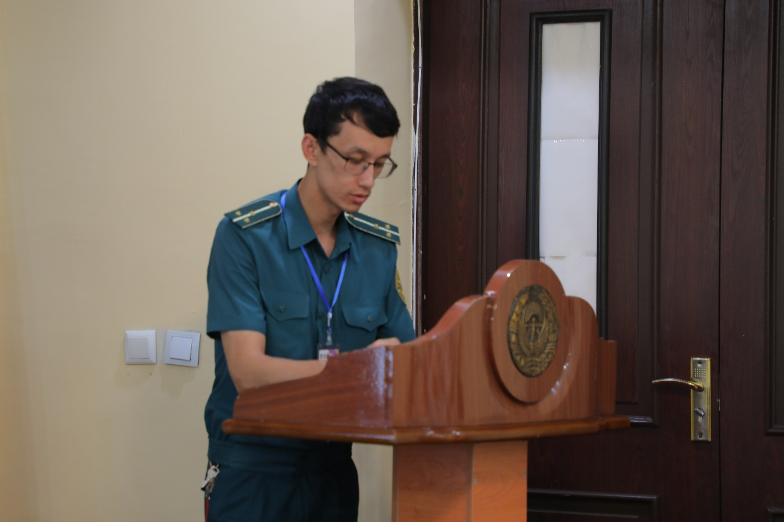

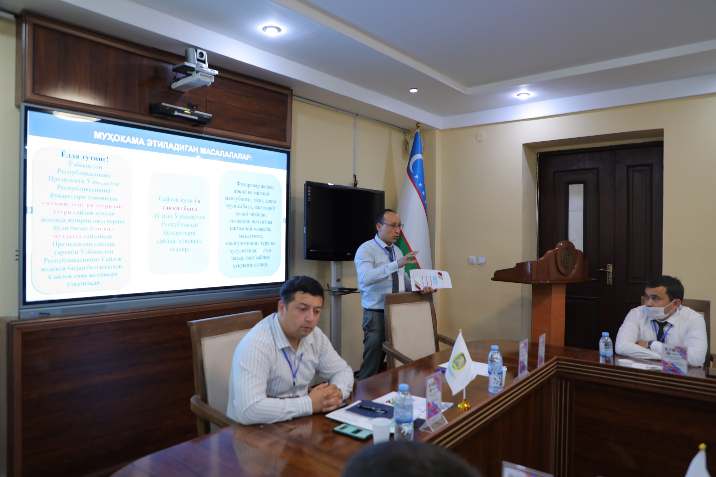

The meeting was attended by industry experts, representatives of relevant organizations.

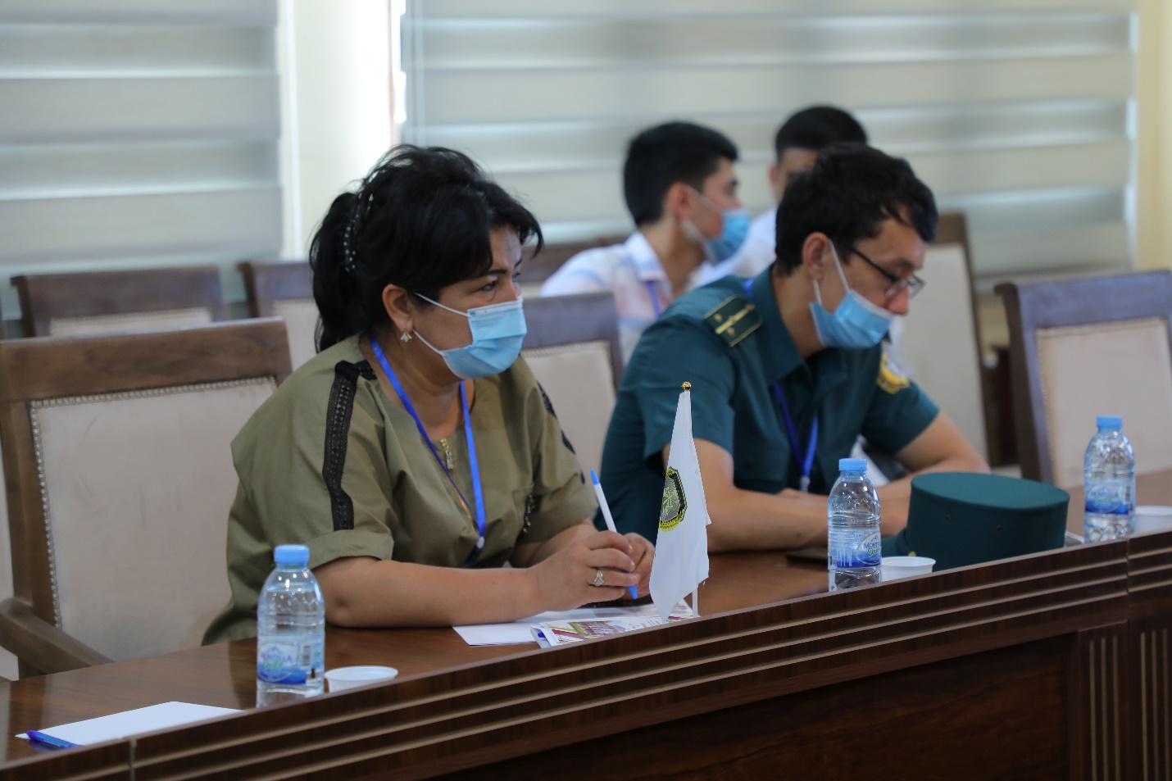

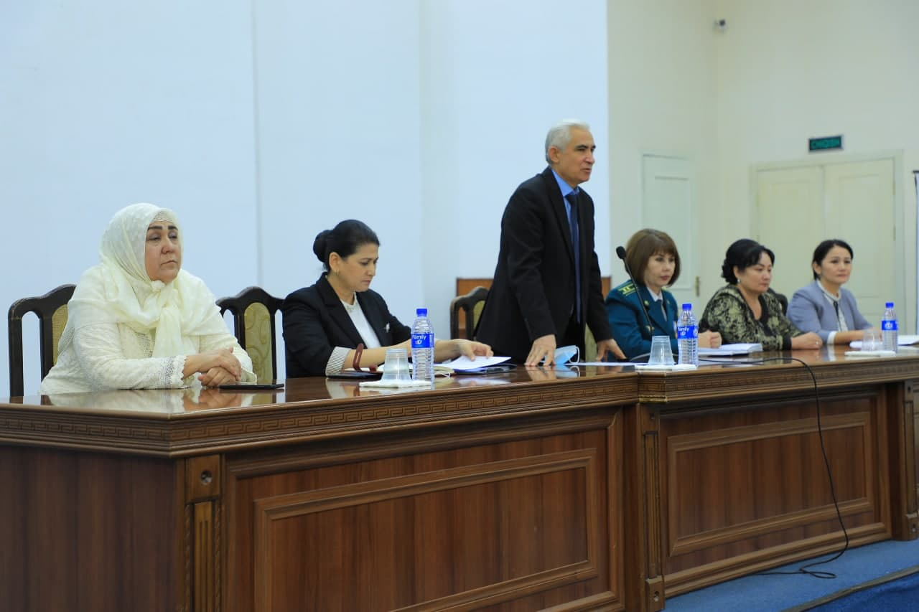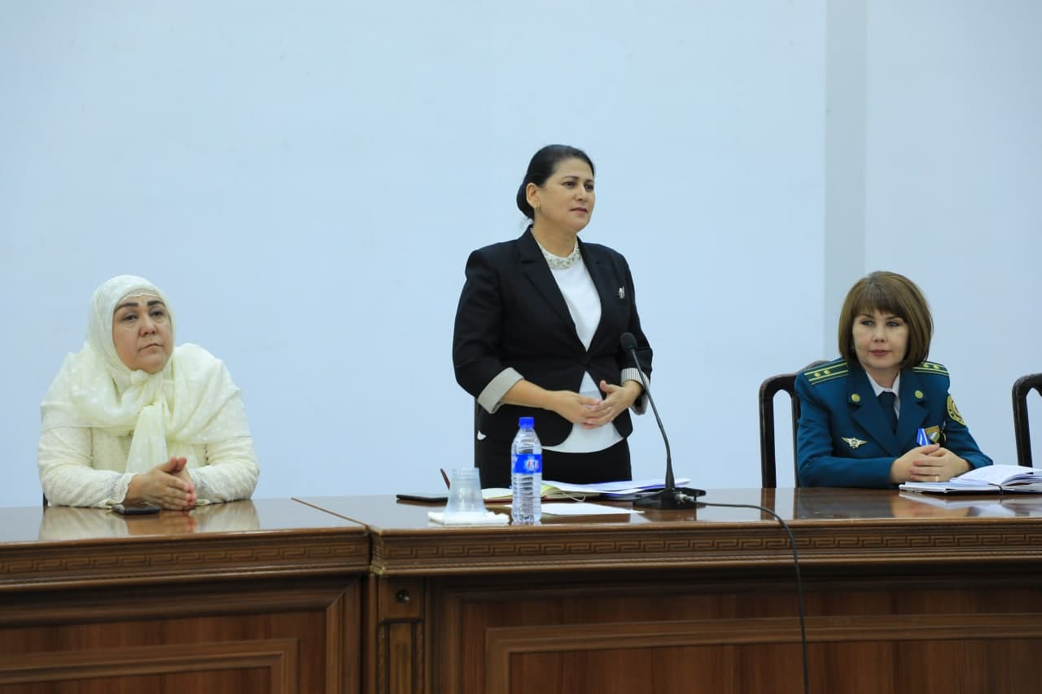

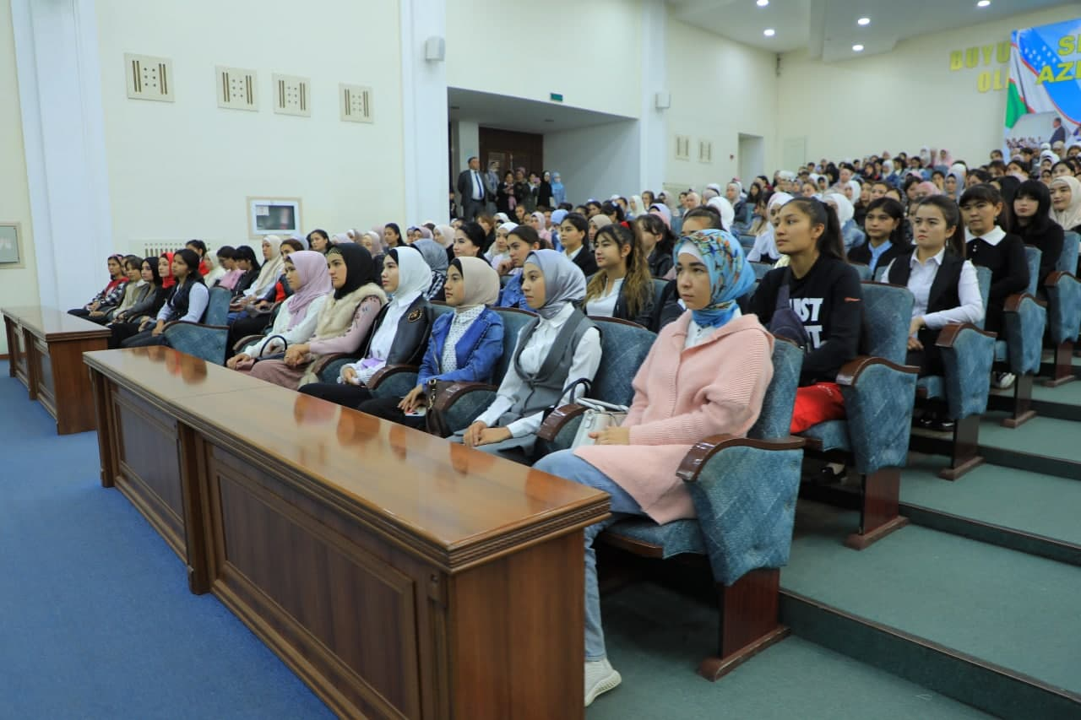

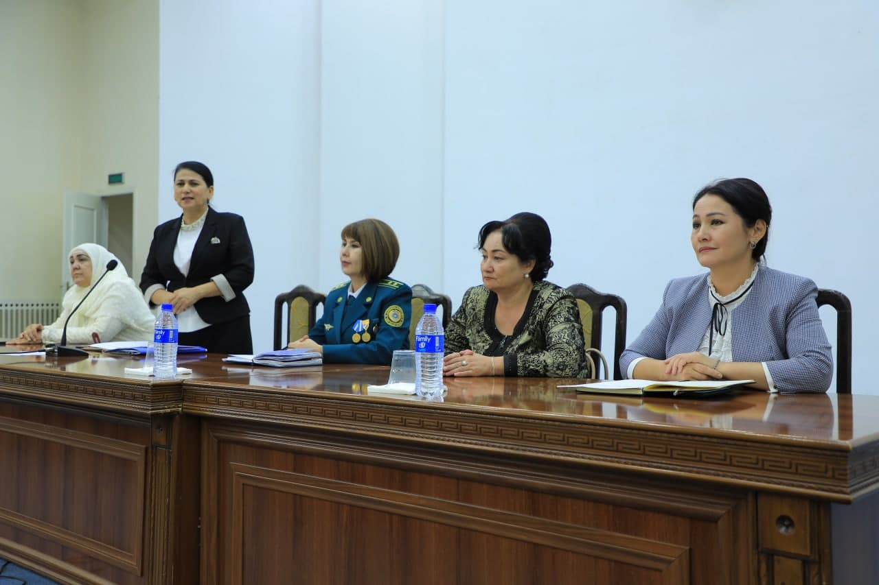

On October 6, 2019, the Women's Council of the University held a roundtable discussion on the formation of a healthy spiritual and educational environment among students, preparing them for family life, mutual respect, dress, culture of communication and behavior, etiquette.

Nizomova Mavluda Sheralievna, Adviser to the Governor on Women's Affairs, 1st Deputy Head of the Mahalla and Family Support Department, Shoirahon Kasimova, Head of the Regional Department of Internal Affairs, Gulnorahon Abduvahidova, Deputy Head of the Regional Department of Internal Affairs, Bobojonova Gulmirakhonlar, Deputy Head of the Department of Health, spoke on "The role of upbringing girls in ensuring the strength of the family", "Culture of dress, communication and behavior of girls", "State policy in protecting the rights of mothers and children, girls' rights, duties, responsibilities" as a factor "exchanged views with students on the topics, expressed their recommendations and suggestions.

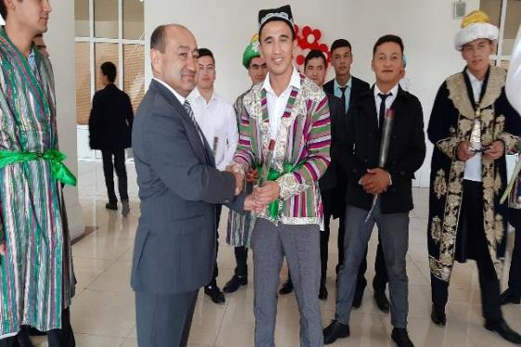

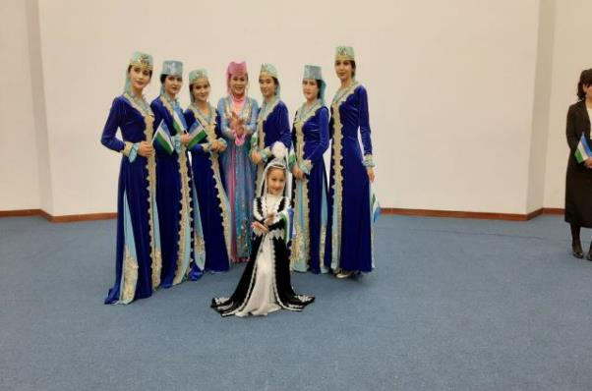

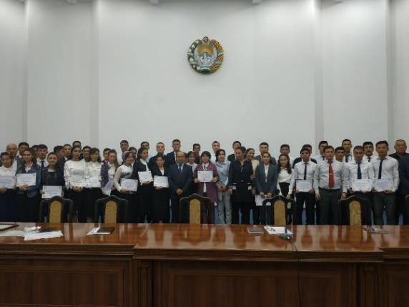

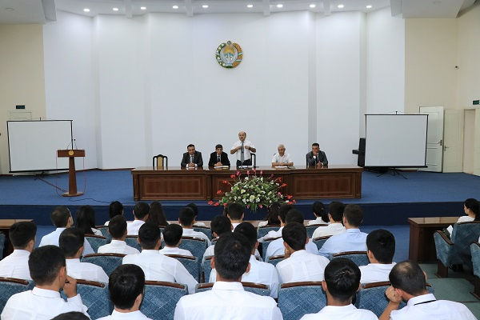

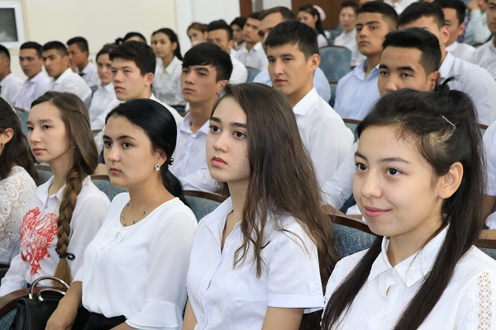

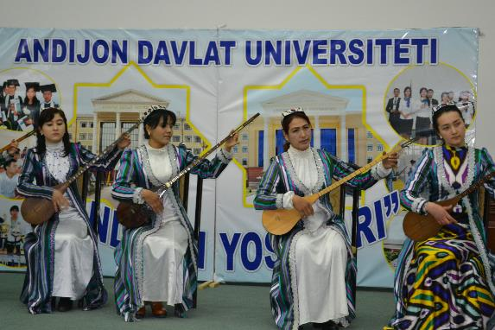

The ensemble "Dutorchi qizlar" consisting of students of music education takes an active part in the spiritual and educational events.

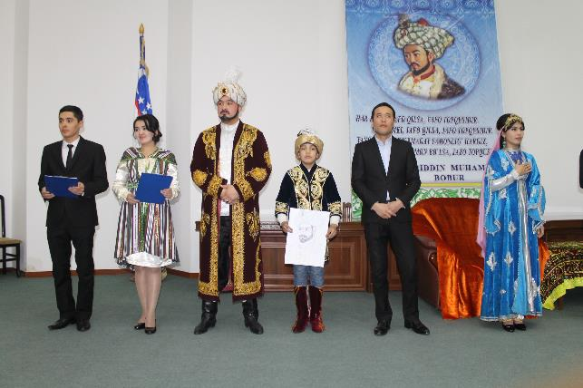

The event dedicated to the birthday of Z.M.Babur was attended by the teams of the student theater studio "Humo" with their performances.

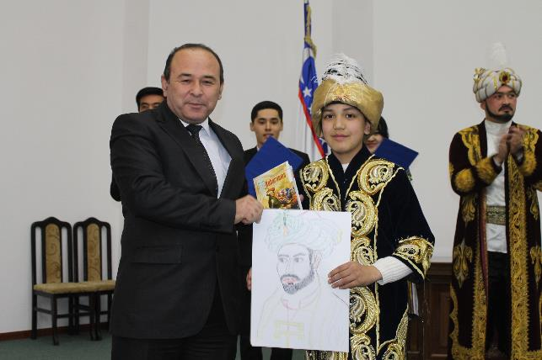

Students of academic lyceums took an active part in the competition of fine and creative works held during the event.